If you purchased our Raspberry Pi 4WD car, you need to perform the following steps:

Step 1: After the car is assembled, you will need to download the Raspberry Pi image we provided.

For the method of downloading the image, please click the location as shown in the figure below, and read the contents carefully.

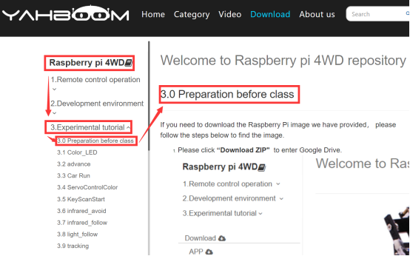

Step 2: You need to burn the image to the Raspberry Pi SD card.

For the method of burning the image, please click the location as shown in the figure below, and read the contents carefully.

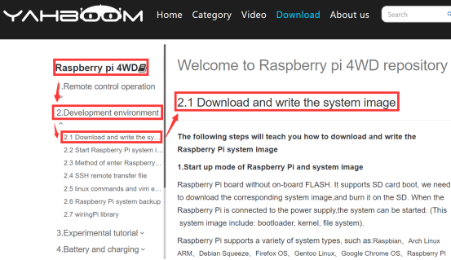

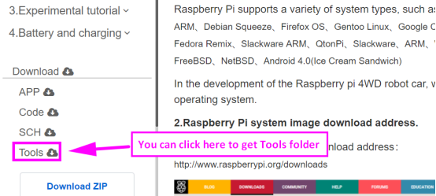

Step 3: After the burning is completed, you need to insert the SD card into the card slot behind the Raspberry Pi, as shown in the figure below.

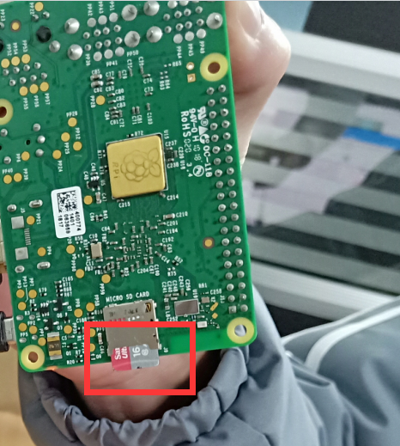

Step 4: You need to connect the Raspberry Pi board to the 4WD expansion board by the 40PIN cable, as shown in the figure below.

 (Please ensure the correctness of the connection)

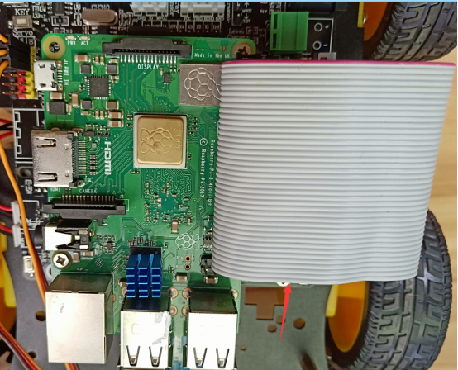 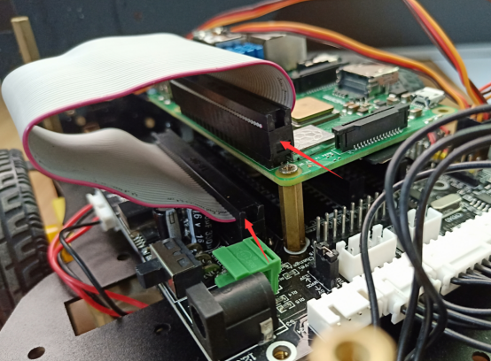

Step 5: Please use the Android phone to download and install the Bluetooth APK we have provided. The download location is as shown below or you can enter the google drive link given in our manual to download.

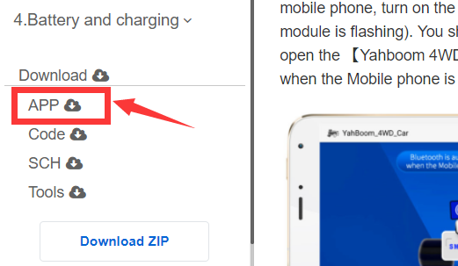

Step 6: After the APP is installed, open the Bluetooth of the your phone, open the power switch of the car, and open the Bluetooth APP. The mobile phone is close to the car, you will see the Bluetooth signal in the upper left corner of the Bluetooth APP interface, as shown below, while the red indicator of the Bluetooth module keeps flashing.

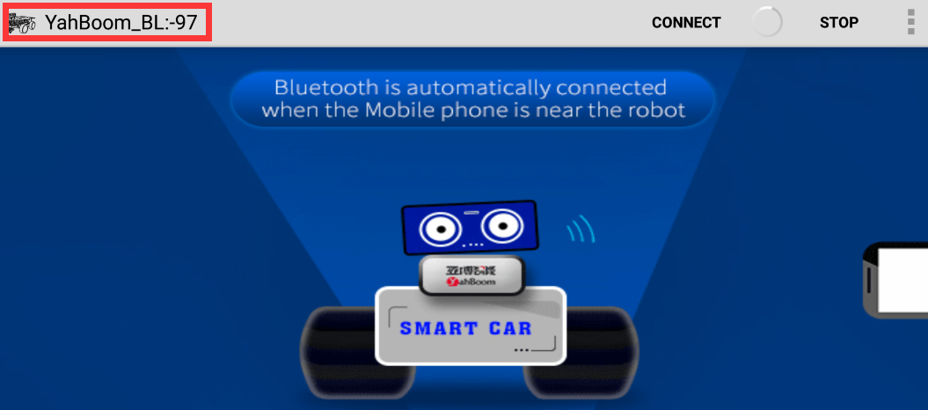

Step 7: The phone will automatically connect to the Bluetooth near the car. If there is no automatic connection, you need to click 【CONNECT】 on the APP interface.

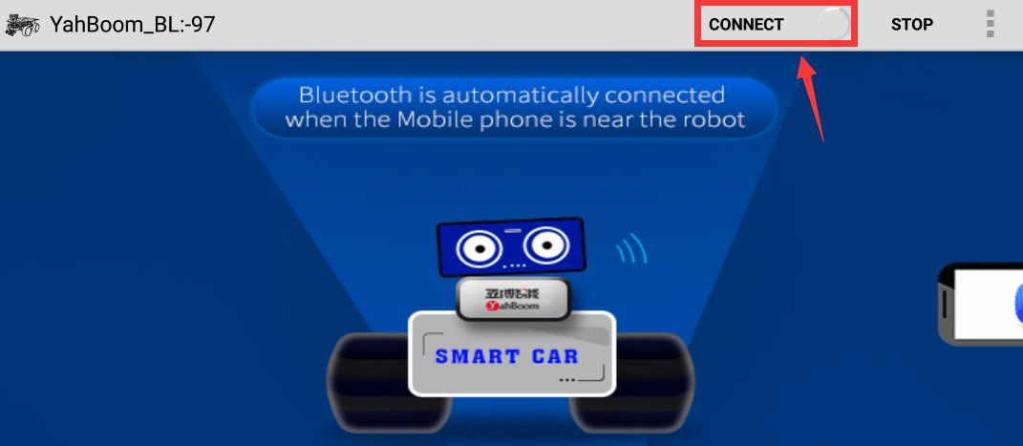

Step 8: Then, Bluetooth can be successfully connected, and the APP will enter the interface as shown below. At the same time, the red indicator of the Bluetooth module will be keep on.

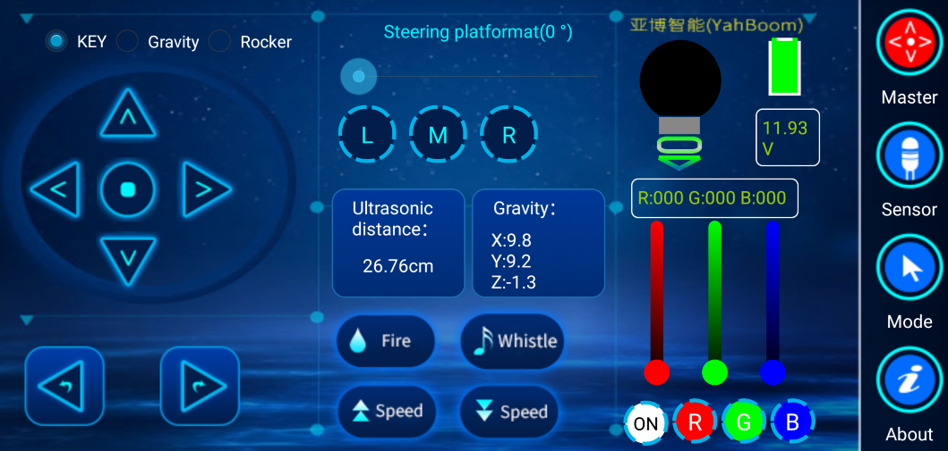

Step 9: Wait for the ultrasonic data to change, it prove that Bluetooth starts to transmit data normally. You can start to control the car.

You need to pay attention to the points, otherwise the Bluetooth remote control function will have problems.

Note:

**(1) The robot car needs to have enough voltage to work properly. Please refer to the following figure for the charging method and battery usage:**

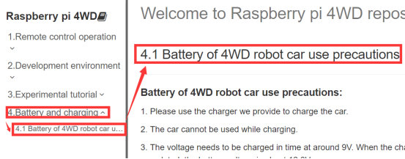

**(2)The Bluetooth module needs to be properly inserted into the expansion board of the robot car. As shown in the figure below.**

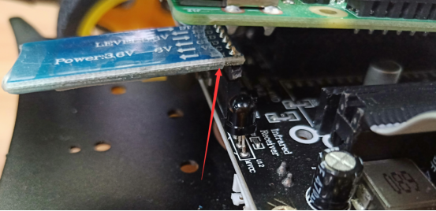

1. **51/Arduino Download Switch on the expansion board must be set to [OFF]. As shown in the figure below.**

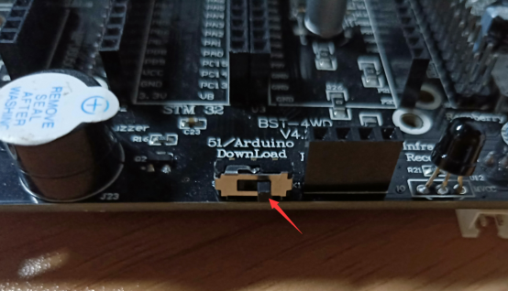

**(4)** The ultrasonic module must be inserted. As shown in the figure below.

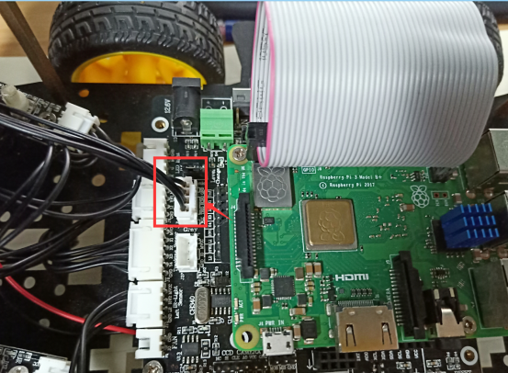

Please read our manual for introductions of Bluetooth remote control interface.